**EXPERIMENT NO- 09**

**AIM:** Implementation of Naïve String Matching Algorithm.

**PROBLEM STATEMENT :** Write a program to implement Naïve String Matching Algorithm.

**RESOURCE REQUIRED:** Pentium IV, Turbo C, Printer, Printout Stationary

**THEORY:**

In the Naive String matching algorithm, we always slide the pattern by 1. When all characters of pattern are different, we can slide the pattern by more than 1. When a mismatch occurs after j matches, we know that the first character of pattern will not match the j matched characters because all characters of pattern are different. So we can always slide the pattern by j without missing any valid shifts. The naïve approach simply test all the possible placement of Pattern P[1 . . m] relative to text T[1

. . n].

The naïve string-matching procedure can be interpreted graphically as a sliding a pattern P[1 . . m] over the text T[1 . . n] and noting for which shift all of the characters in the pattern match the corresponding characters in the text.

**ALGORITHM :**

NAÏVE_STRING_MATCHER (T, P)

1. n ← length [T]

2. m ← length [P]

3. for s ← 0 to n - m do

4. if P[1 . . m] = T[s +1 . . s + m]

5. then return valid shift s

**INPUT:**

Main String: “ABAAABCDBBABCDDEBCABC”, pattern: “ABC”

**OUTPUT:**

Pattern found at position: 4 Pattern found at position: 10 Pattern found at position: 18

**CODE:**

#include <stdio.h>

#include <string.h>

#include <conio.h>

int main (){

char txt[] = "1011101110";

char pat[] = "111";

int M = strlen (pat);

int N = strlen (txt);

int i;

for(i = 0; i <= N - M; i++){

int j;

for (j = 0; j < M; j++)

if (txt[i + j] != pat[j])

break;

if (j == M)

printf ("Pattern matches at index %d \n", i);

}

getch();

return 0;

}

**OUTPUT:**

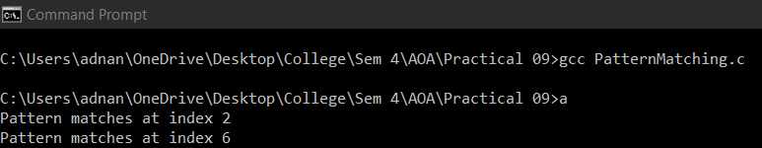

**CONCLUSION:** The running time of the algorithm is O((n - m +1)m), which is clearly O(nm). Hence, in the worst case, when the length of the pattern, m are roughly equal, this algorithm runs in the quadratic time. One worst case is that text, T, has n number of A's and the pattern, P, has (m -1) number of A's followed by a single B.